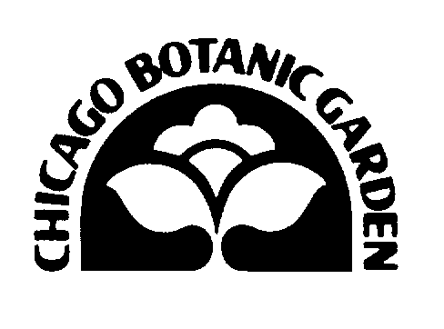
REGISTRATION FORM

Growing Communities Workshop

Chicago Botanic Garden

January 31-February 1, 2002

Yes! I would like to attend. Enclosed find my check for $75 payable to the Chicago Botanic Garden.

No, I am not able to attend, but I would like the Growing Communities curriculum for $35.

Name _______________________________________________________
Organization __________________________________________________
Address ______________________________________________________
Phone ________________________ Fax ___________________________
Email ___________________

Send registration form to: Chicago Botanic Garden
Attn: Eliza Fournier
1000 Lake Cook Road
Glencoe, IL 60022

REGISTRATION FORM

Growing Communities Workshop

Chicago Botanic Garden

January 31-February 1, 2002

Yes! I would like to attend. Enclosed find my check for $75 payable to the Chicago Botanic Garden.

No, I am not able to attend, but I would like the Growing Communities curriculum for $35.

Name _______________________________________________________
Organization __________________________________________________
Address ______________________________________________________
Phone ________________________ Fax ___________________________
Email ___________________

Send registration form to: Chicago Botanic Garden
Attn: Eliza Fournier
1000 Lake Cook Road
Glencoe, IL 60022

