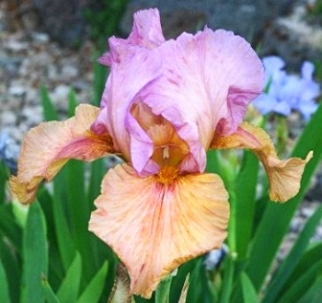
DESERT FESTIVAL OGB- (Lin Flanagan, R. 1994). Sdlg. 89026-1. AB, 26” (66 cm), E. S. pale violet; style arms violet; F. golden tan, blended violet with darker rays extending from throat; beards pale orange gray; ruffled; falls semi-recurved; no fragrance. Close Contact X New Moon. Aril Society, 1996.

