Phylogeny of the genus Iris based on DNA sequence data
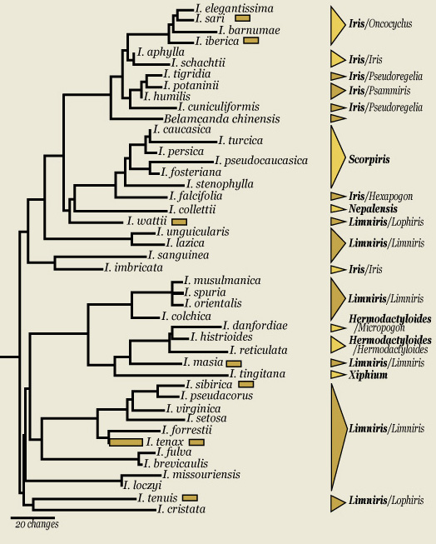
Research from Carol A. Wilson, 2004. based on chloroplast matK gene and trnK intron sequence data. Molecular Phylogenetics and Evolution 33: 402-412.

Goals
To test the current hypothesis of evolution for Iris by determining if subgeneric and sectional divisions within the genus are monophyletic (comprise one lineage).

Data
The matK gene is an approximately 1.5 kb protein-coding region between two highly conserved exons (segments) of the trnK gene. Nucleotide sequence data of the gene and portions of the trnK introns on either side of the matK gene were used. The combined data set had 1996 nucleotide characters of which 24% were variable within Iris.

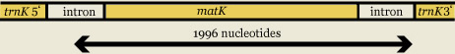

Analysis
Maximum likelihood where the most likely tree based on the data and chosen model of nucleotide evolution was used. For this analysis I used the HYK-85 + G model which assumes the following. The nucleotide composition of the data set will be unequal. Transitions (interchanges between pyrimidines, C & T, or between purines, G & A) occurred more frequently than transversions (interchanges between pyrimidines and purines). The probability that nucleotide changes would occur was not evenly distributed across the data set. The model was chosen based on a comparison of the fit between the data set and potential models of nucleotide substitution.

Important Findings

Placement of Belamcanda chinensis
Belamcanda chinensis was resolved within Iris at the base of the subgenus Iris clade. Goldblatt and Mabberley (2005) published a name change to Iris domestica since I completed this study. This species was considered distinct from Iris because it had sepals and petals that were similar (homophyllous). This placement indicates that the ancestor to Iris domestica probably had a typical heterophyllous Iris flower.

Polyphyly of subgenus Limniris
In this study, subgenus Limniris was resolved as a polyphyletic (comprising more than one lineage) assemblage with eight separate origins. In addition, neither of the current sections (Limniris and Lophiris) and only some of the series are monophyletic. Previous researchers (Lawrence, 1953; Mathew, 1989) recognized subgenus Limniris as a natural group based on the lack of sepal beards and presence of rhizomes. Dykes (1913) placed subgenus Limniris species in two sections. These two sections were Evansia, species with sepal crests, that are now in subgenus Limniris section Lophiris, and Apogon, non-crested species that are now placed in subgenus Limniris section Limniris. Lawrence suggested that the crested species might not be a natural group.

Placement of I. falcifolia
My data places I. falcifolia as sister to the bulbous subgenus Scopiris. Iris falcifolia (subgenus Iris section Hexapogon) is an ususual Iris with small flowers, long stems and a geophytic structure that has been interpreted as a small rhizome (Dykes, 1913). The materials I studied had swollen leaf bases, slightly swollen roots and lacked rhizomes. Early workers either placed I. falcifolia into section Regelia (Dykes, 1913) or placed it with species from sections Regelia and Psammiris into an inclusive section Hexapogon (Lawrence, 1953; Rodionenko, 1987). More recently, researchers have segregated Hexapogon and suggested a close relationship with Regelia (Mathew, 1989), or considered it distinct from other groups (Taylor, 1976). Although the affinities of the two species currently in section Hexapogon have been disputed by previous researchers, all have considered them within subgenus Iris. My results indicate that I. falcifolia should not be placed with other subgenus Iris species.

Sections Pseudoregelia and Psammris are not monophyletic
Species relationships within the sections Pseudoregelia and Psammiris have been controversial. Dykes (1913) did not recognize section Psammiris species as distinct and placed these species in either section Pseudoregelia or section Iris (his section Pogoniris). Lawrence (1953) placed some species from section Psammiris into section Hexapogon and others with some species from both sections Pseudoregelia and Iris into his subsection Pogoniris series Pumilae. The remaining Pseudoregelia species were left in subsection Pseudoregelia. Rodioninko (1987) combined Psammiris and some Pseudoregelia species with section Hexapogon species. Similar to Larwence (1953), Rodioninko left some species within subsection Pseudoregelia. The current assignment of species into sections Pseudoregelia and Psammiris is based on Taylor’s (1976) work that segregated out section Psammiris species. He considered the sections Pseudoregelia and Psammiris to superficially resemble each other in size and floral morphology but to differ in rhizome morphology with section Pseudoregelia possessing compact rhizomes and section Psammiris slender, spreading rhizomes. Mathew (1989) followed Taylor’s circumscription of these two sections.
Species currently circumscribed as belonging to sections Pseudoregelia and Psammiris are montane Asian species with I. humilis extending into Europe. Based on my observations I. tigridia and I. potaninii share morphological features such as tuberous roots, fiberous leaf remains, low tufted stature, membraneous bract-like leaves at the base of each stem and small arils on their seeds. It is surprising that previous researchers dismissed these similarities as superficial. A small aril is also present on seeds of I. humilis and is reported to be present on other species of these sections (Rodinonenko, 1987).

Conclusions
This study has made progress in resolving relationships within the large and diverse genus Iris, although considerable work remains. Belamcanda chinensis (Iris domestica) is placed within Iris. Both of the two largest subgenera, Limniris and Iris, are polyphyletic as currently circumscribed. The small section Hexapogon does not belong within subgenus Iris. Species within subgenus Limniris have undergone at least eight separate origins. Sections Pseudoregelia and Psammris are not monophyletic

Acknowledgements
I thank the UC Berkeley Botanic Garden for leaf material and access to living collections of Iridaceae. I also thank Maia Akhalkatsi, Nina Alexeeva, Lisa Karst, Marine Mosulishvili, Mary Pfauth and Erdogan Usta for sending me plant material for this study and students Nicole Andrus and Tim Brock for help in the Laboratory. The American Iris Society and National Science Foundation (DEB-0416377) provided funding for this project.

References
Dykes, W.R. 1913. The Genus Iris. Dover Publications, Inc., New York, NY.
Goldblatt, P. & D.J. Mabberley. 2005. Belamcanda included in Iris, and the new combination I. domestica (Iridaceae: Irideae). Novon 15: 128–132
Lawrence, G.H.M. 1953. A reclassification of the genus Iris. Gentes Herbarum. 8, 346-371.
Mathew, B. 1989. The Iris. Batsford Ltd., London, UK.
Rodinonenko, G.I. 1987. The Genus Iris. (English translation) The British Iris Society, London UK.
Taylor, J.L. 1976. A reclassification of Iris species bearing arillate seeds. Proc. Biol. Soc. Washington. 89, 411-420.

